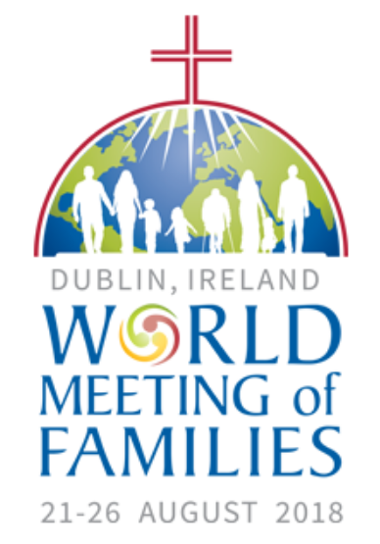 Request for WMOF2018 Hosts/Volunteers/Final Mass

On behalf of the World Meeting of Families, Marino PPC asks for your help today.
Pope Francis himself personally chose Dublin, Ireland to host the 9th World Meeting of Families. The World Meeting will run from the 21st. to the 26th. of August 2018.
- The WMOF organisation needs people willing to host pilgrims coming to World Meeting of Families. If you have a spare room, we are asking people to open their homes for the week of August 20th to 27th and provide bed and breakfast and a Céad Míle Fáilte.
- The WMOF also needs your help by volunteering at the event. 7000 additional volunteers are required. www.worldmeeting2018.ie
- Tickets for the Congress, Croke Park, and the Phoenix Park can be booked by anybody who wants to attend.
- If you would like to be part of a group which will attend the Final Mass on Sunday 26th August 2018 in the Phoenix Park as a Parish, please fill in the form at the back of this sheet. We do not know how many tickets will be made available to the Parish as a group. If we have sufficient numbers we may organise a coach to take us.
- There is space on the form also to indicate if you are interested in either being a Volunteer or Hosting pilgrims. We will pass this information onto the WMOF. Please return the form to the Parish Office by June 10th.
- Full details about hosting a pilgrim and volunteering or attending can be found on our website – www.worldmeeting2018.ie.

Area of Interest | NAME  [Please write in BLOCK LETTERS] | Email address | Telephone number
Volunteer

Hosting a Pilgrim

Attending the Final Mass in the Phoenix Park as a Parish *
If interested in attending the Final Mass, how many tickets are required?

To be returned to the Parish Office by June 10th.2018

