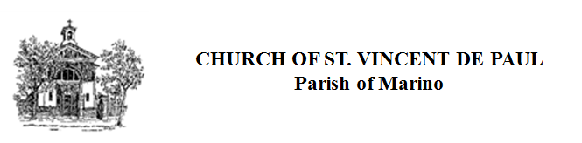

Feast of the Immaculate Conception
December 8th 2018
Mass Arrangements

St. Vincent de Paul Church , Marino
December 7^{th.} Vigil Mass 5.30 p.m.
December 8^{th.} Feast Day Mass 10 a.m.
December 8^{th.} Feast Day Mass 11 a.m.

St. Joseph’s , Rosmini
December 8^{th.} Feast Day Mass 10.30 a.m.

