MARINO CHURCH- VOLUTEER STEWARDS TRAINING CHECKLIST

Guiding Principles: Best practice.
- Closed Spaces: Ventilation / Hand washing / Using sanitizer / Respiratory practices (Capturing sneezes on tissues / coughing into arm / face covering).
- Contact: One Way system -separate entrances & exits /Limited permissible seating/ Distance between seating /No kneeling /No singing/ Cleaning post service.
- Crowds: One Way system -separate entrances & exits / 2M distance between seats/ Face coverings.
Training requirements:
- GDPR form for new volunteers.
- Steward’s Self Declaration guidelines.
- Volunteer rota form.
- Review Steward’s Check list.
- Walk through.
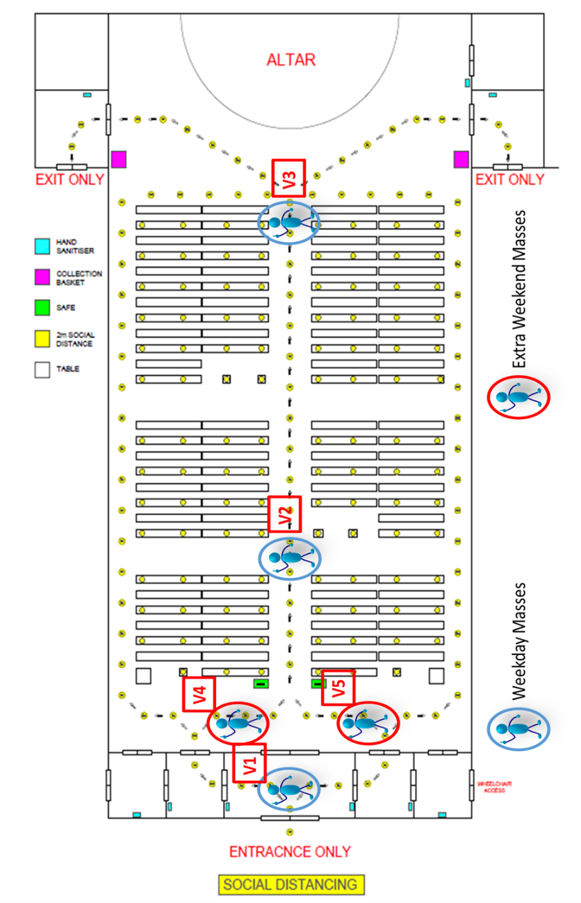
Key Points:
- Top Section = 48 people, rear section = 48 people.
- Volunteers to please arrive 30 minutes before the service- through the Marino room.
- If a Volunteer is unwell, please do not come to the Church.
- The Leader will assign roles for the service, communicates (particularly when rear section is in use) and keeps a look out for issues.
- The doors are opened 15 / 20 minutes before the service.
- The Leader will ensure that the side doors are unlocked before the service started.
- Leader/Volunteers: Please ask for help from the congregation for cleaning etc. if short of Volunteers.
- On occasion, additional cleaning pre-Service, may be required i.e. in case of funeral on the previous day. This will be communicated to the Leader of the Day.
- Where a member of the congregation/volunteer become ill- move people away from area- -keep person in their seat-call an ambulance and wait for them to arrive. One person to stay with person- be mindful of Social distancing and hygiene etiquette.

Volunteer Roles:
Name | Volunteer / Roles
Before Mass
V1 | Volunteer in Porch – 1 Volunteer
- Welcome people! Invite people to use hand sanitizer.
- Ask people to follow Stewards and do as they request.
- When limit of top section (48) is reached – Move to erect full house sign -slow flow of people- 5 people or so at a time. When church limit (96) is reached – stop flow of people – close doors.
- Ensure people outside know that Holy Communion can be offered.
- Stay to rear of Church, once ceremony starts.
V2 | Volunteer in Church- Leader/Key holder/Float.
- Welcome people! Guide people to up Centre aisle, remind people to observe Physical distancing: 2m markings & arrows on floor/ single file/ guided to your seat/ one-way system.
- Remind people of contact tracing data- Name/contact number – into Safe.
- Control flow of people into Church -count.
- When top section limit (48) is reached – communicate to Porch - Move to erect full house sign.
- When limit (96) is reached – stop flow of people – close doors.
- Stay to rear of Church, once ceremony starts.
V3 | Volunteer in Church- Seating- 1 Volunteer
- Welcome people! Guide people to their seats.
- Fill seats from the top of the Church, and from the middle of the pews out. Max. 4 people per pew or family of 5/6/7. Keep a few outer seats free for those of reduced mobility.
- When limit (48) is reached – communicate to Leader – put up Stop sign in centre of aisle.
- Move to Rear section and start to fill sears from those closest to the altar.
- Stay to rear of Church once ceremony starts.
V4 / V5 | Volunteer in Church- Guiding
- Welcome people! Guide people to up Centre aisle, remind people to observe Physical distancing: 2m markings & arrows on floor/ single file/ guided to your seat/ one-way system.
- Remind people of contact tracing data- Name/contact number – into Safe.
- When limit in top section (48) is reached – Assist Porch with managing batches of people into Rear section.
- Stay to rear of Church once ceremony starts.
During Mass
Assigned roles | Volunteer in Church – during Mass –min. 2 Volunteers in each section.
- Open Outer side doors after Homily. Use outside route- weather dependant.
- Check to see if there are people outside / in cars in the Church grounds who might like Holy Communion.
- Steward from Rear section accompanies Minister of Eucharist to rear of Church.
- Manage Holy communion Route: one-way system. Move to Altar when Priest moves to get Chalice for congregation. Two people- one manages each side. Use centre aisle in single file (Right side first – St. Vincent DePaul Altar) to receive Communion and return to seat via side aisle.
- Rear section – ropes in the lower section of the side aisle to allow one-way system.
Assigned roles | Volunteer in Church – After Mass – Altar Section – 2 Volunteers
- Move to side porches post Communion. Open 2nd inner door.
- Manage exit routes – one person on each side. Encourage people to leave by side aisles – in sequence- seat by seat- starting with those seated nearest the Altar.
- Point out sanitiser & collection basket.
- Floating person moves up and down centre aisle encouraging people to leave using the side aisles.
 | Volunteer in Church – After Mass – Rear Section- 2 Volunteers
- Close Centre outer doors at entrance to Church. Open both sets of Outer Side doors.
- Ensure Inner side doors are open.
- Manage exit routes – one person on each side. Encourage people to leave by side aisles – in sequence- seat by seat- starting with those seated closest to the rear.
- Point out sanitiser & collection basket.
- Floating person moves up and down centre aisle encouraging people to leave using the side aisles.
After Mass – Assist with cleaning. Ensure all side doors are locked (weekday), ensure centre entrance doors are open. Thank you!

