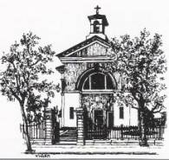
Church of St. Vincent De Paul, Marino, D09 KN83

V. Rev. Tom Noone, Parish Priest: Tel: 8332864
Parish Office: Tel: 8332772
RCN No: 20016166
E-mail: info@marinoparish.ie
Website: www.marinoparish.ie
Twitter: @marinoparish
[Type a quote from the document or the summary of an interesting point. You can position the text box anywhere in the document. Use the Drawing Tools tab to change the formatting of the pull quote text box.]

Mass Times

Weekdays:
10.00 a.m. (Monday to Friday)

Saturday:
10.00 a.m. & 5.30 p.m. (Vigil)

Sunday:
9.15 a.m. & 11.00 a.m.

Eve of Holy Days:
7.00. p.m. (Vigil)

Working Holy Days:
10.00 a.m. 11.00 a.m.

Eve of St. Patrick’s Day:
5.30 p.m.(Vigil)

St. Patrick’s Day
9.15 a.m. & 11.00 a.m.

Bank Holidays:
10.00 a.m. (Church closes at 11.00 a.m.)

Eucharistic Adoration

Saturday:
5.00 – 5.30 p.m.

Confessions:

Saturday:
10.30 a.m. - 11.00 a.m. & 5.00 p.m. - 5.30 p.m.

Thursday - Eve of First Fridays:
After 10.00 a. m. Mass

Baptisms:

Baptisms take place on the 2nd Saturday of the month at 12.00 noon.
Pentecost Sunday 5th June 2022
Thought for the day

The four marks of our Christian belonging are our personal journey, our community belonging, our practical discipleship and our adult integration of faith and life. None of us “inhabits” all four dimensions fully, all of the time, and yet all four dimensions should in principle be there. The good news of Pentecost is that the Spirit, poured into our hearts, enables all four aspects of our faith to live: the Spirit helps us in our prayer; the body of Christ is animated by the gifts of the Spirit; our service of others gets its energy from the Spirit and the Spirit “reminds us” of all that Jesus taught. Today, we celebrate discipleship in the community of faith.

Prayer

We open our hearts and lives to you, Holy Spirit: breathe a breath of new life into us all!

Please return Mass leaflets and yellow notices (if not taking home) to back of Church
Thank you.


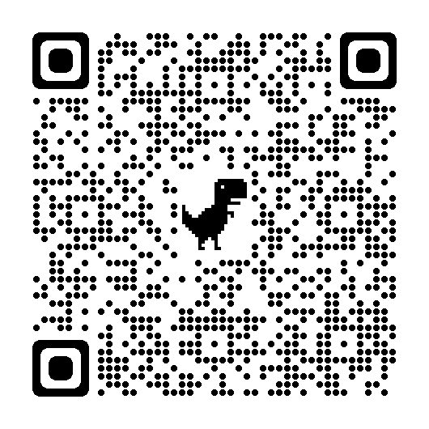
The Building Hope process has begun in our parish. This initial phase involves us identifying the strengths of our parish and the areas in need of development. We are also asked to suggest partnerships with other parishes that might be beneficial in terms of resource sharing. A parish gathering has been planned for Tuesday 14th June in order to explore these areas. An invitation to this gathering along with the parish statistics are available to take home. The Building Hope Task Force Report can be accessed by scanning this QR code.

FIRST COMMUNION

Congratulations to all our 2nd class pupils who celebrated First Communion during the month of May. They were all excellent and well prepared in understanding the importance of this special moment of faith in their lives. Congratulations to their parents and wider families and a special word of thanks to their teachers, to the schools and to all involved in the various ceremonies.
Our final 'Do This in Memory Mass' on our First Communion journey will be celebrated at 12.30pm next Sunday, June 12th. All First Communion families are invited to return to celebrate together and the children are invited to come in their First Communion outfits.

PRAYERS FOR EXAM STUDENTS

There are bookmarks available at the back of the church with prayers for Exam Students. We will be keeping all our students doing state exams in our prayers over the coming few weeks. If you would like us to pray for a particular student, please place their name in the box provided beside the Altar.

PENTECOST SUNDAY - GIFTS OF THE SPIRIT

Today is Pentecost Sunday when we celebrate the birth of the church and the coming of the Holy Spirit with all its gifts. Please take a gift of the Holy Spirit from the baskets at the back of the church and perhaps also a gift for family members!

FEAST OF ST. ANTHONY

The Feast of St. Anthony occurs on 13th June and the Novena Prayer will be recited each morning at the 10.00 a.m. Mass from 4th June to 12th June – Prayer cards at the back of the Church, please take one.

MEDJUGORJE PRAYER GROUP:

Medjugorje prayer group meetings continue every Thursday from 8.00 p.m. to 9.00 p.m. in the Annadale Room.


EUCHARISTIC ADORATION:

Please note there will be no Eucharistic Adoration in Clonturk House, Ormond Road this Sunday due to Bank Holiday – it will resume as usual next Sunday from Sunday 7.00 p.m. until 8.00 p.m.


CHURCH SHOP/REPOSITORY:

The Church Repository/Shop is open every Tuesday and Thursday morning after 10.00 a.m. Mass and after 11.00 a.m. Mass
on Sundays. Communion Cards, Gifts & Rosettes Available.

SOCIETY OF ST. VINCENT De PAUL

The Society of St. Vincent DePaul will hold their usual monthly church gate collection next weekend 11th/12th June 2022

SPARE ROSARY BEADS & USED STAMPS


If you have any spare Rosary Beads, please drop them into the Sacristy for patient use in Beaumont Hospital.
We would also appreciate any used stamps you may have.

SCOUTS – 1st Dublin Fairview

Two patrols from scouts have qualified for the Scouting Ireland Phoenix Challenge in Limerick in August – to help them on their way there is a cake sale in the den this Sunday 5th June from 10.00 a.m. to 2.00 p.m. – your support would be much appreciated.

PRAYER FOR THE SICK:
Please pray for all in the parish who are seriously ill.

RECENTLY DECEASED:

MONTHS MIND:

ANNIVERSARIES:

Helen Murphy
Paddy & Nora Murphy
Noreen Taaffe
Catherine O’Reilly
Kathleen Coleman
Terence O’Rourke
Winifred Donegan
Avis O’Brien

